4

Desert Research and
Control Desertification in Iran

M.Pakparvar
Research Institute of Forests & Rangelands,
Tehran - Iran P.O.Box 13185-116
E Mail: Rifr@Jsis.neda.net.ir

Abstract

After more than 40 years of executive programs and 3 decades of research activities for solving desert problems, a large quantity of reclimed desertic area has been ready for life of human communities. The most important experience is; to rational management of water, specially utilization of flood flows in arid regions is the key for solving the problems. Furthermore, sharing the people (who are the actual owners of the lands) , is the only successful way to desert sustainable rehabilitation. The paper presents some more information about the subject.

Geomorphology

Iran, the longitudinal section of a conch with a sort of hollow in the eastern part of the center, resembling a mother-of-pearl shell, lying on its back. This hollow in the center is formed by the different mountain ranges along the northern, western and eastern borders of the country.

The Alborz range on the north extends from west to east with its highest peak reaching about 6000 meters. The Zagros mountain range on the west extends right from the north-west along the west to south-eastern end, its highest peak reaching nearly 5000 meters. On the east the high plateau forms the edge of this hollow. One of the most peculiar geomorphic and geological features of these mountain ranges is that, whereas the taller ranges mostly consists of limestone and igneous formations, there is always a parallel low and auxiliary range, formed mostly of gravel and mud hills.

Thus the entire hollow of the Iranian plateau is surrounded by a series of gravel and mud hills. Generally there is far less precipitation on these mud hills than on the tall ranges. The soil loosend in these mud slopes by the perennial trampling of myriards of feet, is at the mercy of the elements. Early spring rains and hot and dry summer winds carry such loosened soil into the central basin. The scars left by the water erosion are visible in the shape of frightening gullies and innumerable rills in the mud hills. This transport of soil is greatly facilitated and accelerated by prevailing geomorphic conditions described above, since the ephemeral streams and drainage channels passing through the hills carry everything down to the plains during their fast descant. The flow of mud increases the arid and saline wastes in the plains. So, the soil salinity is a common problem for most of the interior plains of hollow because of salty minerals movement to the closed or semi closed basins. Moreover, ancient dried (evaporate) lakes have formed large saline and/or clayey areas in the lowest parts of basins which is named ”Kavir”.

Climate

More than 90 percent of the land area in Iran is classified as arid or semi-arid. Of the 164.8 million hectares of whole area of the country, the mean annual precipitation of the 87 million ha of the mountainous regions and 77.8 million ha of the plains areas are 365 mm and 115mm, respectively (Annon,1984).

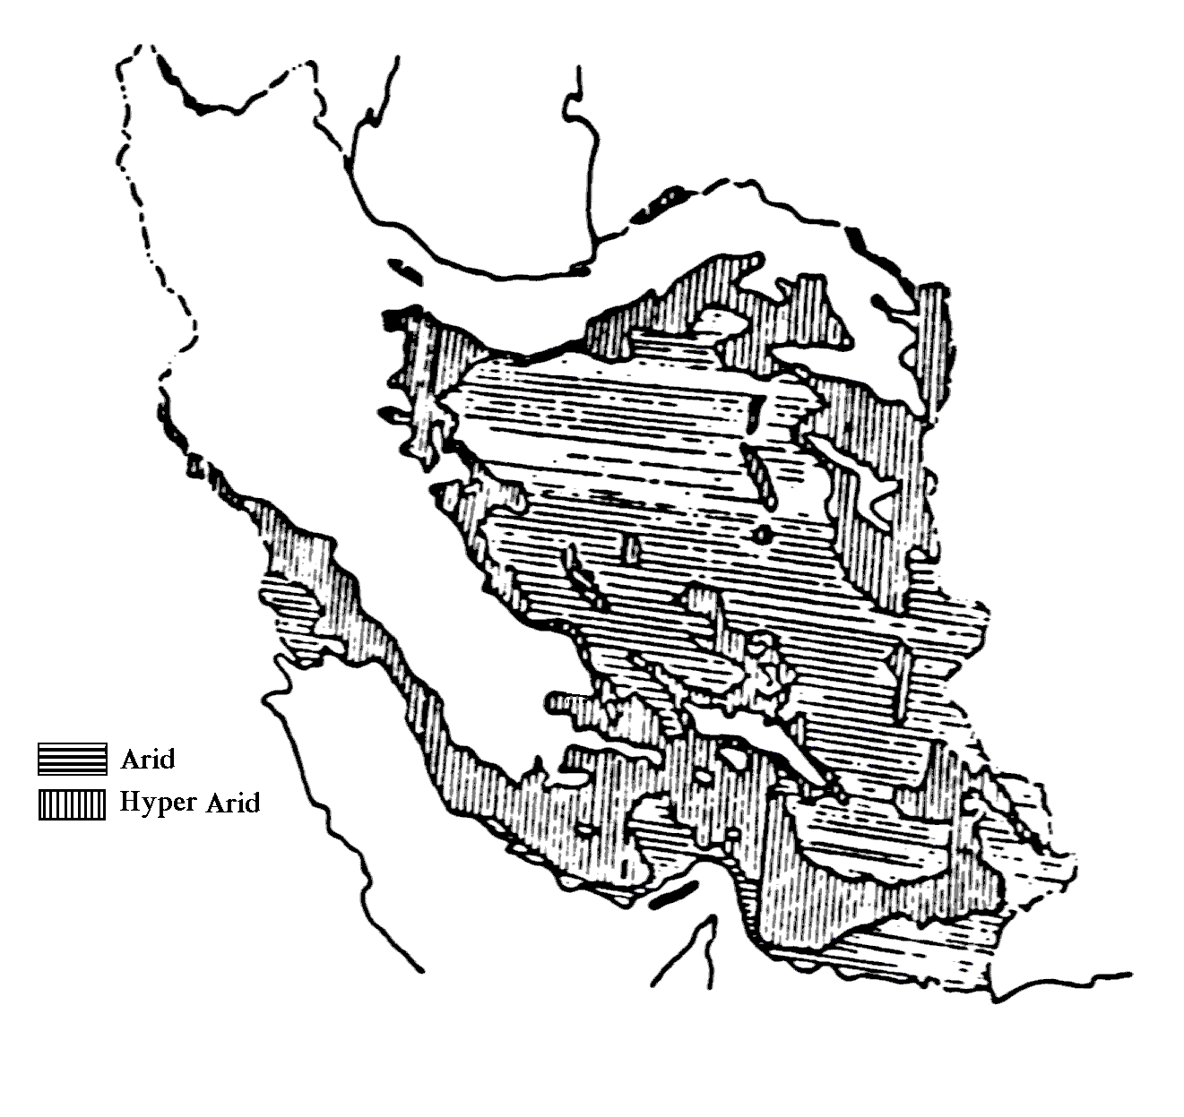Figure 2: Distribution of arid climate in Iran

Approximately one-half of Iran's water supply comes from surface waters, with most of the remainder coming from groundwater aquifers which are significantly over drown. Therefore, drought is an ever present threat to most of Iran, (Figure 2).

Ironically, periods of drought are often punctuated by flood producing downpours that devastate the drought stricken people and their living things.

Distribution of deserts

Even though, there is a variation in reports on quantity of deserts areas in Iran, because of different definitions; some real estimations showed that, at the present the area of desert regions and sandy lands is estimated to be 34 million hectares (5 million ha active and 12million inactive sands and remain areas is salt accumulation lands, saline and alkaline soils, gravelly lands, etc.), and that of the poor and desertified rangelands which is 16 million, it reaches to 50 million hectares (Annon,1993). There is a great integrated survey to definition and mapping Iranian deserts, for getting actual numbers.

Executive programs

The first committee for soil and water conservation was established in 1958 in collaboration with F.A.O. This committee decided some measures to stabilize shifting sand dunes and in 1959 a small scale research project was put into implementation in an area of 10 ha in Khuzistan province. In 1965 another sand dune fixation project was carried out in an area of 100 ha in sot part of Khorasan. Because of successful results obtained from the accomplishment of the projects, it was immediately developed in other parts of the country, facing the same problems. These projects mostly consist of a) Biological operations; b)Physico-chemical activities.

Biological includes plantation of seedlings and cuttings, seeding, and enforcement of closures. Haloxilon persicum, H.ammodendron, Atriplex lentiformis, A. conescence, Caliganum spp.,Artemizia spp., Tamarix hispida, T. katchy, Robinia psudo accasia, Eucaliptus kamaldulensis,and some other drought tolerant species were used for sand dune fixation and deser trehabilitation.

Physico-chemical operations (for temporary stabilization of unstable soils and sand dunes) include petroleum mulch spraying, wind breaks, checkerboards, etc., which provide suitable conditions for plantation and/or natural regeneration.

Since the beginning of the sand dune fixation project up to now, more than one million hectares has been potentially under exploitation. Presently, The average biological production in the reclaimed land is 200 kgs and total annual production amounts to 200000 tons. Of the 8million ha has been organized for rehabilitation, and reclamation programs; 4 million ha are now under work.

The program for next 25 years (up to year 2025) is to manage 11 million ha of dessert and desertified area by the government and 12 million ha by private and social activities with cooperation of government by technical and fundamental aids and financial supports of banks. The rehabilitators will be owners of the reclimed areas in according to new lows.

Desert research activities

Through more than 30 years of Iranian desert research activities, a large quantity of research projects has been carried out for solving desert problems and to introduce and improvement measures for control desertification.

The most important result of 3 decades of desert research in Iran can be summarized as the concept of flood water utilization which is the key for combating desertification in most of the arid environments.

Iran and desertification

For better understanding the importance of water management in dry regions, here is a need to recognition the water cycle in Iran. According to published data of a 25 years period (up to 1994), the average accessible water in country is 125.3 billion m³ (bcm) or 30.3% of total annual precipitation (413.2 bcm). Remain 69.7 is out of access because of evapotranspiration. 25% of accessible water, infiltrate directly and recharge the aquifers which supply about 55% of annual water needs, while 33 bcm of surface water provides the rest, (Table 2).

Table 2: Sub surface water balance in Iran

Recharge (bcm) |  |  | Discharge (bcm)
Kind of recharge | Volume | % | Kind of discharge | volume | %
Evaporation from surface | 4.02 | 7.1 | Infiltration in highlands | 17.455 | 34.3
Subsurface exit from country | 0.955 | 1.7 | Infiltration in plains | 8.057 | 15.8
Drainage | 6.008 | 10.6 | Infiltration from surface flow | 10.151 | 20
Well & Qanat | 47.079 | 80.6 | Infiltration after use | 15.222 | 29.2
Total | 58.062 | 100 |  | 50.885 | 100
Source: H.M.Arefi and M.Darvish (1996)

The volume of surface runoff which annually drains into outer and interior reservoirs adds up to 53 bm³ if a substantial amount of this flow could be saved, a major portion of our water demands would be satisfied. Furthermore, according to reported data, there is a minus groundwater balance especially in the arid and semi-arid farmland regions. According to Table 3, the pressure of water consumption from good quality aquifers, seriously increased from 18.88 bcm in year 1977 to 149.4 bcm in 1994. (Figure 3). So, the movement of saline groundwater beneath the arable areas is expectable, and soil surface salinization is the obvious result.

In the same time, there is an acceleration trend in number of flooding through recent years (Figure 4), which is the obvious result of land degradation specially in arid regions. Use of flood water which is the common feature of arid regions of Iran, as the resource of artificial recharge of aquifers is a rational way to over come the problem. In addition, to being economically feasible and environmentally sound, flood utilization may be under taken with local traditional skills and experience, enabling desert communities to become self sufficient in water, food, forage and fuel.

Table 3 - Comprehensive water consumption of resources in Iran

Well and Qanats
Year | Numbers | Discharge | Discharge from unit
1977 | 76489 | 18.8809 | 246.8
1982 | 93203 | 22.1403 | 237.5
1986 | 190237 | 38.5788 | 202.8
1990 | 249829 | 41.0285 | 164.2
1992 | 264434 | 43.154 | 163.2
1994 | 292478 | 47.079 | 161.0
Percent of change | 282.4 | 149.4 | -34.8
Source: H.M.Arefi and M.Darvish (1996)

Pilot project of flood spreading system

Pilot area is a 6000 ha sandy expanse located on the debris cone of the Bisheh Zard river in Gareh Bygone plain . The mean annual precipitation is about 150 mm,90 percent of which occurs between October and April. The mean annual evapotranspiration is estimated to be 2860 mm. There is a hot summer and cold winter temperature.

Eight flood water spreading system, ranging from 25 to 365 ha in area with a total coverage of 1365 ha, were designed and constructed between 1983 and 1987 on the intermediate zone of debris cone (Figure 5). The procedure used are a modification of those outlined by Quilty (1972). The systems serve as sedimentation basins and infiltration ponds for the artificial recharge of groundwater; and also as experimental plots for investigation range improvement, moving sand stabilization, afforestation, etc. (Kowsar, 1992).

Transformation of a desolate, sandy expanse into a verdant horizon is the most obvious result of the flood water spreading pilot effort. The expansion of irrigated fields in what was previously a water-short area is conveniencing evidence of the effectiveness of the measure. Increasing the amount of groundwater, decreasing of its salinity, prevention the flood hazards, is the other benefits. From Jan. 1983 through Feb. 1988 there were 21 floods of varying intensity and duration. It is estimated that a total of 38 million m³ diverted by the system and 25 million m³ were directed to reaching the groundwater under unimproved conditions, less than 10 percent of precipitation finds its way into the groundwater aquifers. In pilot area, grazing capacity has became 10 times and yield of farmlands reaches to two times more than the past.

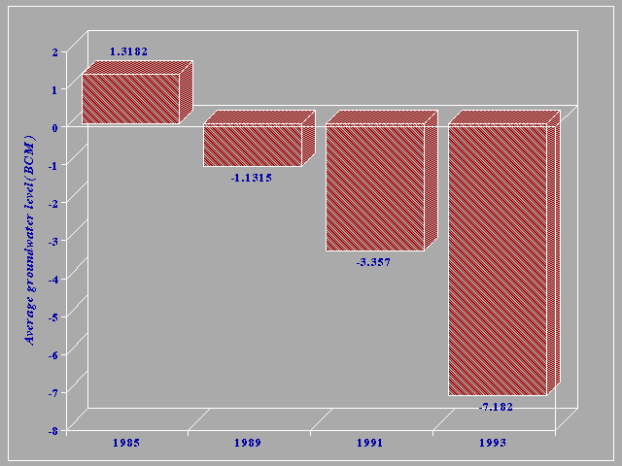
Figure 3: Trend in change of aquifer budget based on recharge and discharge data

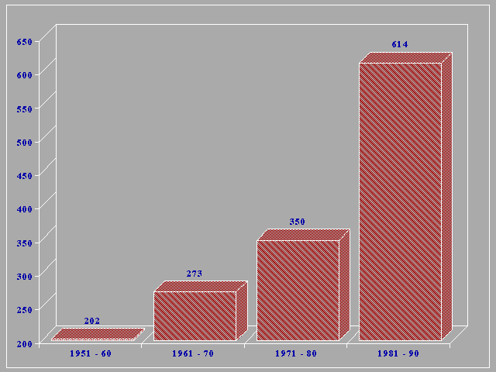
Figure 4: Number of flooding through recent 40 years
The project has been performed by A.Kowsar and its group of cooperators. In 1996recognized as the best watershed management project in the world by UNDP.

At present, the same projects has started in 20 sites of desert regions of country and handreds of young educated persons as well as the local people are being work at the projects. Most of the alluvial and piedmont plains of arid environments having floody rivers with coarse grain and deep aquifers, are suitable for this measure. In Iran, determined that near to 14 million ha of unarable lands can be change to farmlands by utilization of flood water (Arefi and Darvish , 1996).

New fields of research

As well as continuing previous activities, there is some other fields of desert research as follows;

- Assessment and monitoring of desertification. This activity is performing as a national and integrated project using remotely sensed data and GIS, which will be complete and update by field investigations. Some general speaks say that there is a 1% trend of desertification in the country, but real data will produce at the end of project.

- Use of new technics of plant breading in order to produce the most tollerant generation of desert plants.

- Improvement and modification of useful and simple to use of water saving methods. For example there is a great project for utilization of clay pipes after especial processing in order to use as sub ground irrigation tools.

- Ascertation the origin of sand dunes. The most effective sand dune fixation activity could be done in the area which is origin of the blown sands. Wind direction and speed analysis, study of sand morphology, finger printing of mineral composition; are the technical ways for recognition the origin of sand dunes.

Conclusion

Improper land use and drought are the principle agents of desertification. Reduced groundwater discharge, a variation of drought, is mainly due to over-exploitation of a limited resource; hence, it is partly man-made; therefore, man has the power to control desertification through proper utilization of land and water . This maybe partially achieved by harnessing the flash floods common to most deserts. Floodwater spreading is the key to desertification control in many parts of the world. This method has materialized in the Gareh Bygone plain, 200 km to the south-east of Shiraz, Iran.
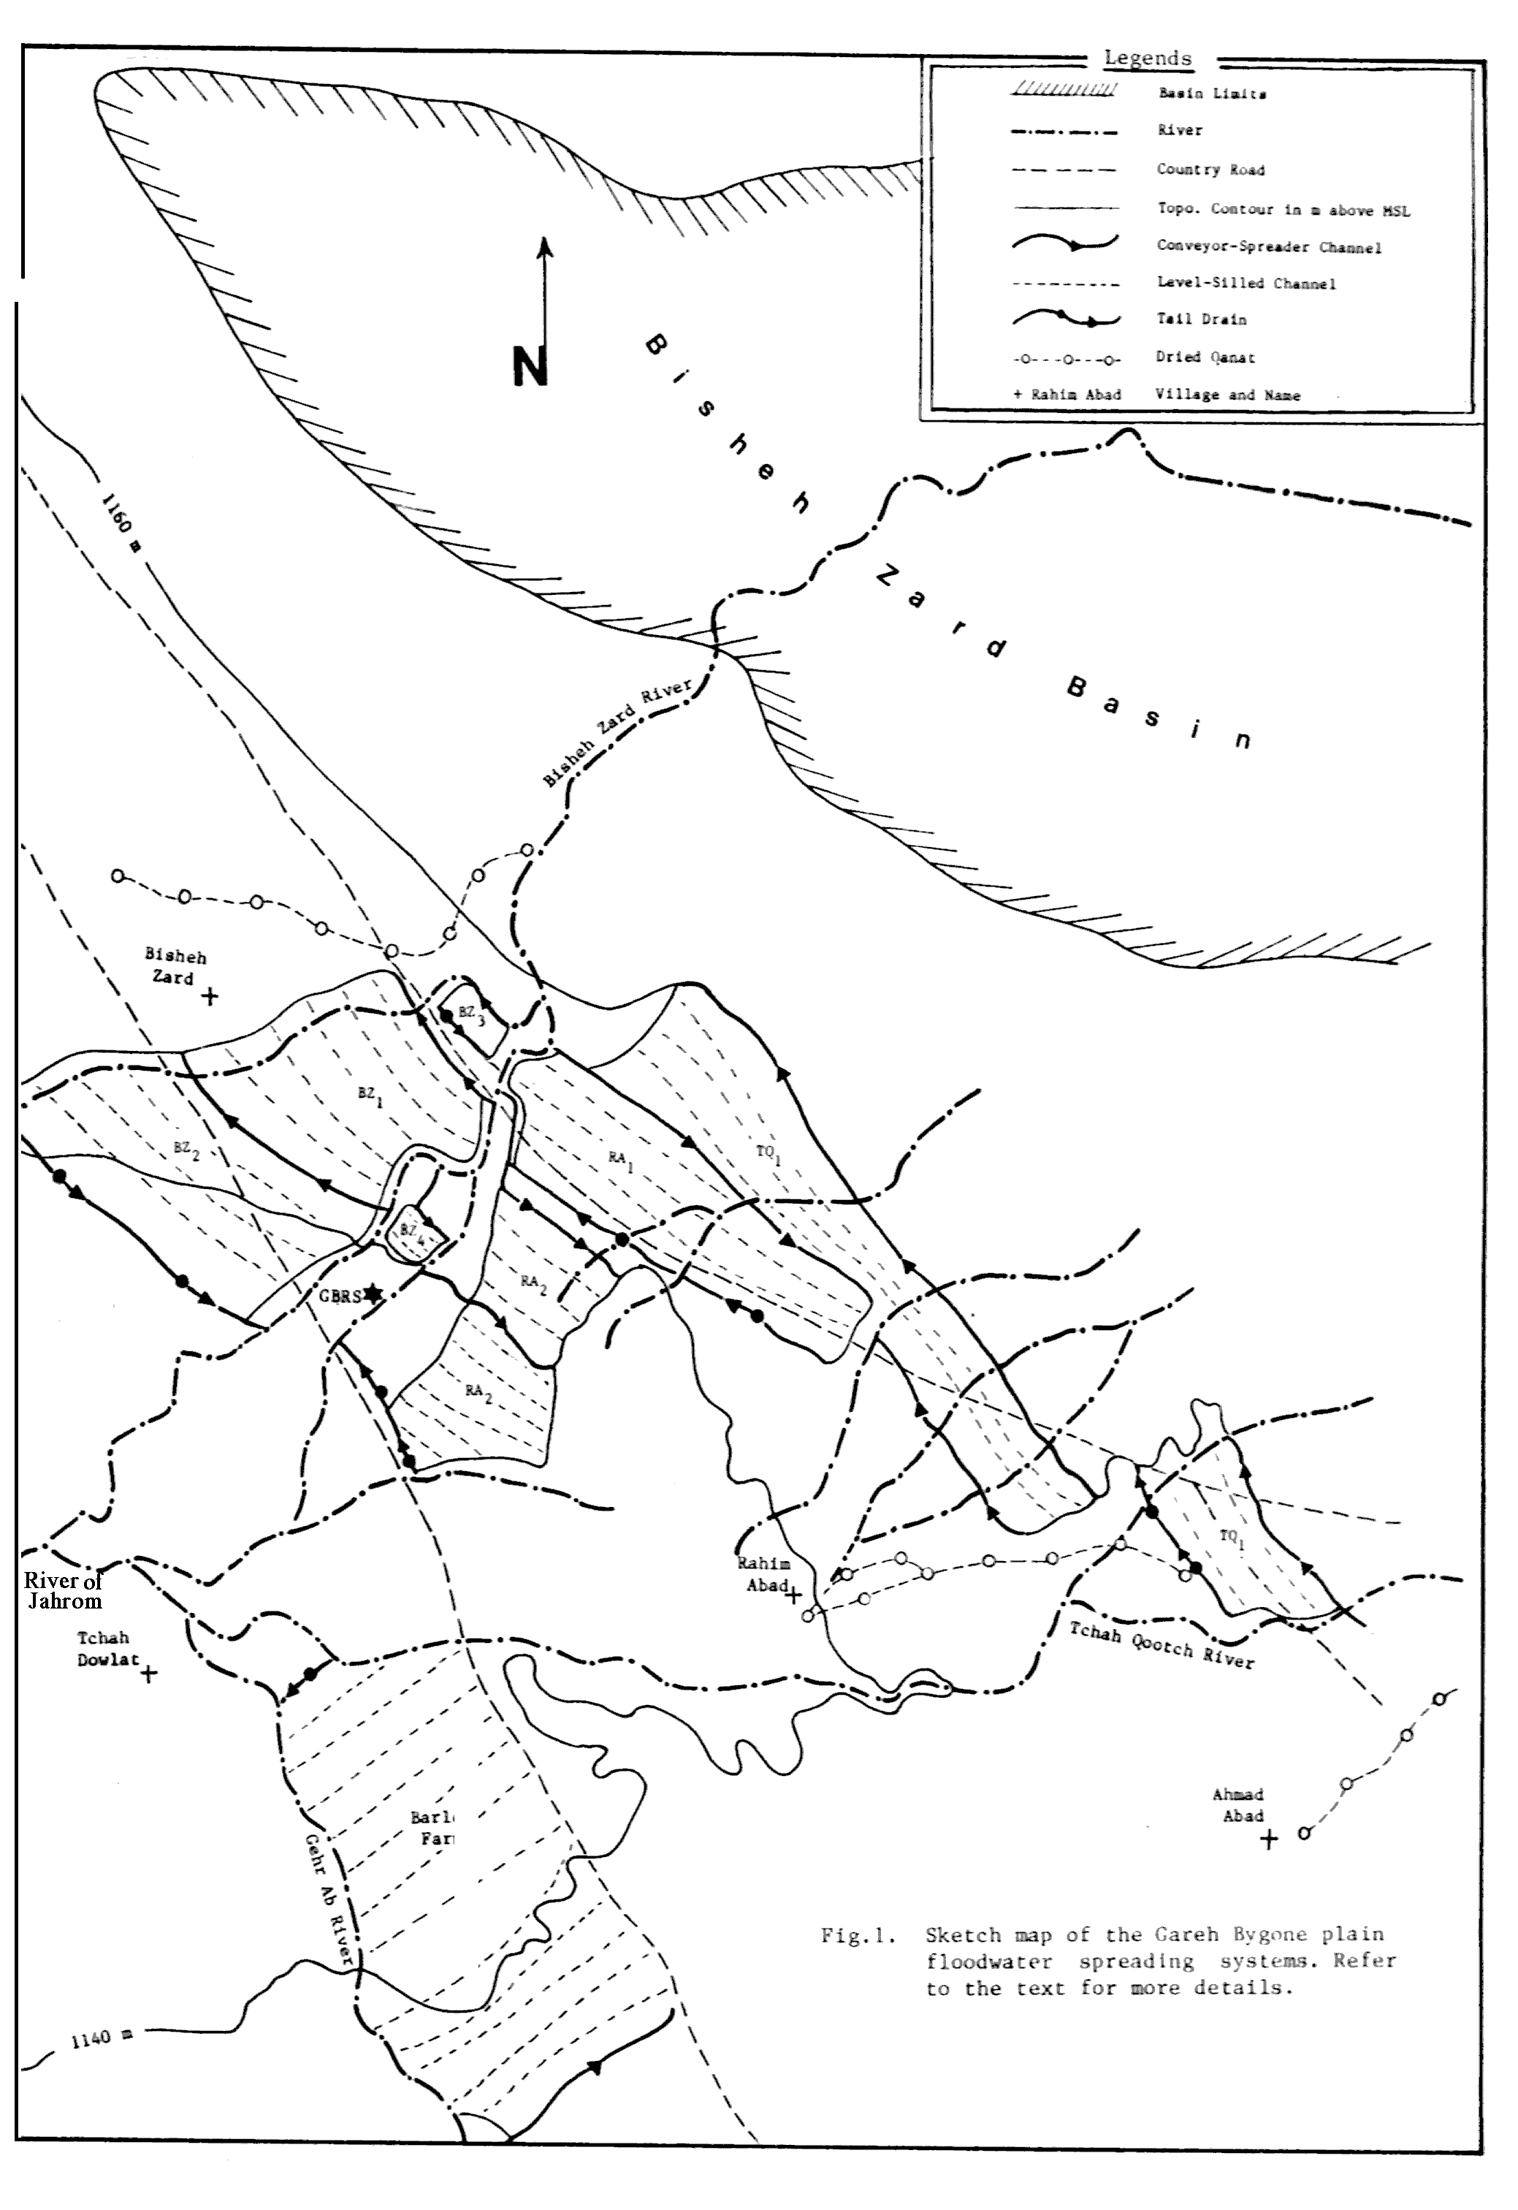
Figure 5: Sketch map of the Gareh Bygone plain floodwater spreading system
References

Anon. 1976. Rainfall and evaporation maps of Iran. Surface water authority, ministry of power, Tehran (in Persian)
Anon. 1994. Desert and desertification in Iran, Bureau of sand fixation and combating desertification, Forest and Range Organization 12 p.
Arefi,H.M. and M.Darvish, 1996. rational utilization of water potential; A lesson for combating desertification, PP 267-285 in: Proceeding of the 2nd national conference on desertification and its control methods, Sep. 1996, Kerman, I.R.Iran (in Persian)
Bhimaya,C.P. 1971, Sand dune stabilization, Report to the government of Iran .F.A.O no. TA2959, 32 p.
Kowsar A. 1991, Floodwater spreading for desertification control: An integrated approach. Desertification Control Bull. UNDP, no.19, 1991, pp. 3-18
Kowsar A. 1992, Desertification control through Floodwater spreading in Iran, Unasylva, 1992/1 43, 27-36
Kowsar A. 1997, An introduction to Flood mitigation and optimization of flood water utilization: Flood irrigation, Artificial recharge of groundwater, Small earth dams, Research Institute of Forests and Rangelands, Tech. Publ. no. 150, 522 p.(in Persian)
Quilty, J.A.1972a. Soil conservation structures for marginal arable areas - Gap absorption and gap spreader banks. J. soil cons. N.S.W 28, pp. 116-130
Quilty, J.A. 1972b. Soil conservation structures for marginal arable areas - Diversion spreader banks and tank drains, J. soil cons. N.S.W 28, pp. 157-168

